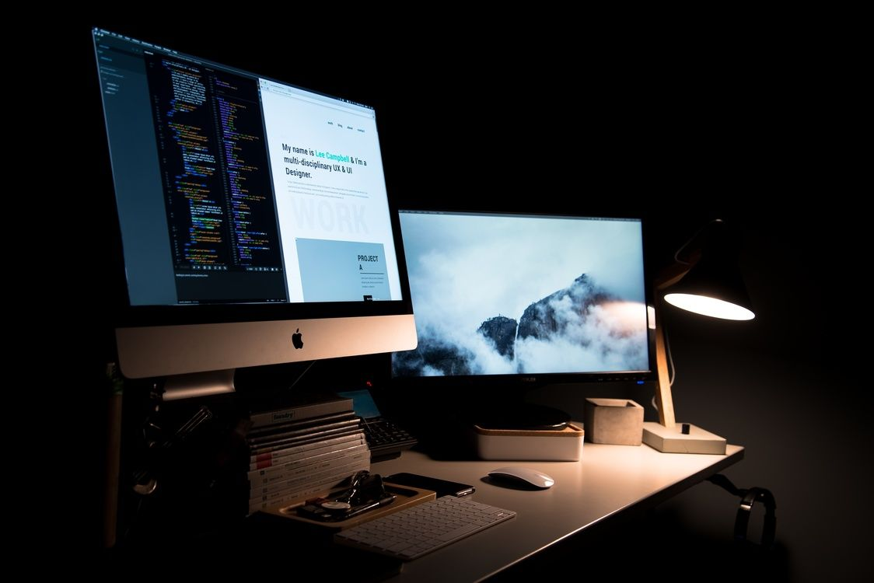

**WEB DEVELOPMENT**

**REPORT**

**NSBM Green University**

**Friday, 24 February, 2022**

**21.1 Batch**

**Group No :6**

**“Ensuring healthy lives and promoting well-being at all ages is essential to sustainable development.**

**Currently, the world is facing a global health crisis of Covid-19”**

**Tittle**

* **This is a web design report. Our mission was to create a website that selects Good Health and Well-being, the 3rd goals of the sustainability goals that are a major challenge today, and addresses them based on the current challenge**
* **There we selected the COVID-19 situation and used our university as a system to retrieve students’ vaccine data introduced through our create website project.**

**1. Introduction**

1. **Introduction**

* **Sustainability Concept**
* **SDE 3rd goals of good health and well-being**
* **NSBM Green university is a university with a successful system for Covid-19 challenges**

1. **Summary**
2. **Conclusion**
3. **References**
4. **Summary**

**2. Summary**

* **This website can prevent a person infected with COVID-19 from entering the university**
* **We created the NSBM green university management website for the COVID-19 pandemic currently facing basic humans for a sustainable development goal of a healthy society, through which we hope to track the spread of pandemic situation by noticing vaccines and non-vaccinated people.**
* **What are the SDG Goals?**

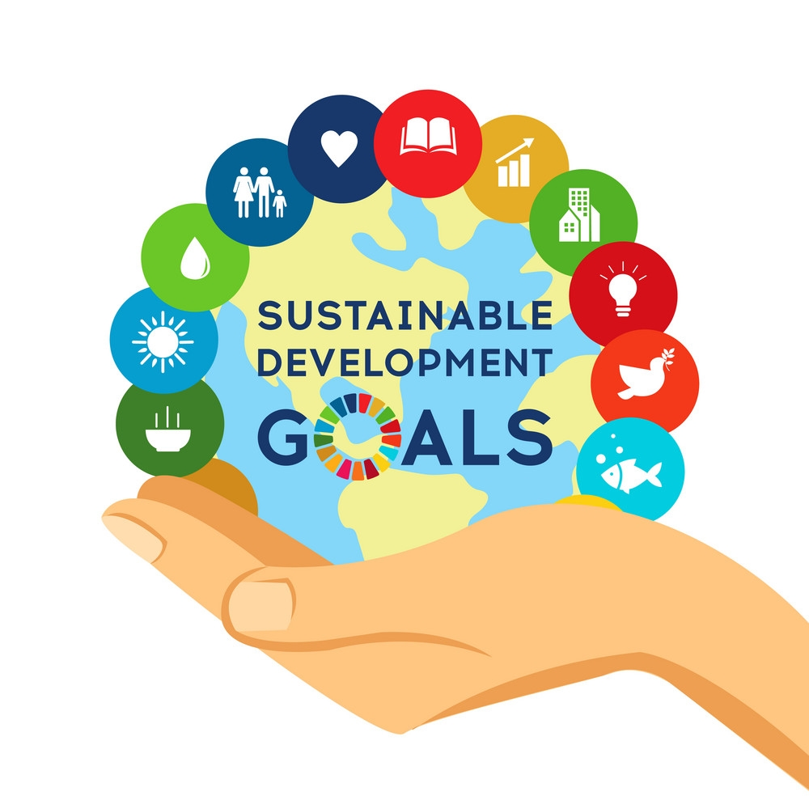

* **In 2015, 195 countries agreed with the United Nations that they can make a positive difference in the world.**
* **This will be done by bringing together their respective governments, corporations, media, higher education institutions, and local non-governmental organizations (NGOs) by the year 2030 to enhance the lives of the people in their respective**

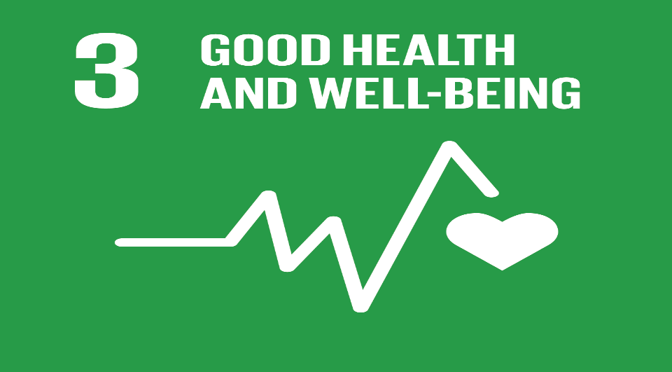**What is Good health and well-being?**

* **Goal 3 of the Sustainable Development Goals aims to ensure everyone's health and well-being at all stages of life. Everyone’s main health issues are addressed in the Goal, including perinatal, maternal, and child health; communicable, non - modifiable, and environmental illnesses; universal health care; and universal access to safe, effective, high-quality, and affordable medicines and vaccinations for all. It also asks for additional research and development, higher health spending, and improved health risk reduction and management capabilities in all nations.**
* **Many student studies in the world were upset and late due to the Covid-19 situation. Universities and schools are now working to start student studies under the new-normal condition**
* **How to face NSBM for COVID-19 and Sustainable goals for good health and well-being?**
* **NSBM Green University is a higher education institution that consistently adapts to the green concept as well as SDG goals. NSBM Green university is also managing the COVID-19 situation that the world is currently facing.**
* **NSBM Green University also manages student vaccine information using technology and maintains a student vaccination information update system.**
* **It is an updated system that can prevent the spread of COVID-19 at the university.**
* **This will confirm whether the student has received the vaccine or not and encourage the non-vaccinated student and inform the students about the place where the vaccine will be given.**

**4. Conclusion**

* **COVID-19, the world's most recent pandemic, has wreaked havoc on the earth. Almost all of the world's continents are now fighting this awful virus, which is dragging the entire planet down economically, socially, and environmentally. We must make restitution as a responsible community for what has gone wrong in many areas, from technology to the environment. As a result of the pandemic, many lessons regarding health practices, social networking, and other issues have been learned. As a result, COVID-19 has harmed learning at all levels, including kindergarten, primary, and secondary schools, as well as other higher educational institutes and universities. As a result, almost every organization, including NSBM Green University Town, has worked to improve the situation.**

**5. References**

**Official Github website**

<https://desktop.github.com/>

**Official W3C Website**

<https://www.w3schools.com/html/html_css.asp>

**The Blogging for Devs Official Website**

<https://bloggingfordevs.com/css-blogs/>

**Youtube Channels**

* https://www.youtube.com/watch?v=yfoY53QXEnI
* https://www.youtube.com/watch?v=mU6anWqZJcc

**Web Pages Created by Students**

**R.A Paranagama**

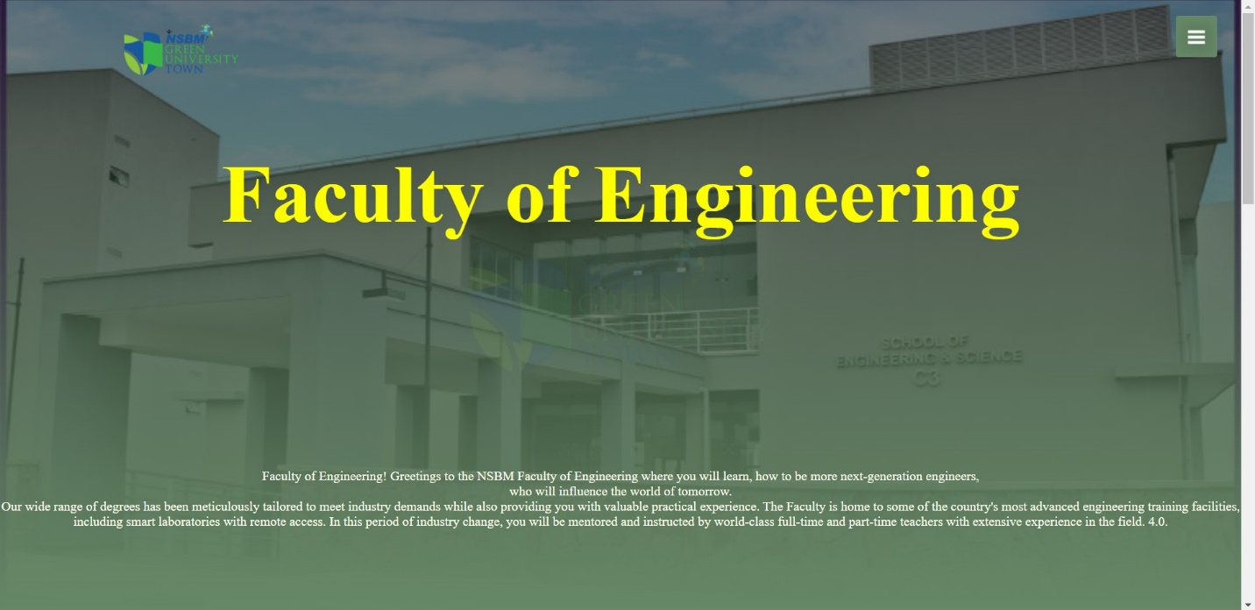**Index No - 23896**

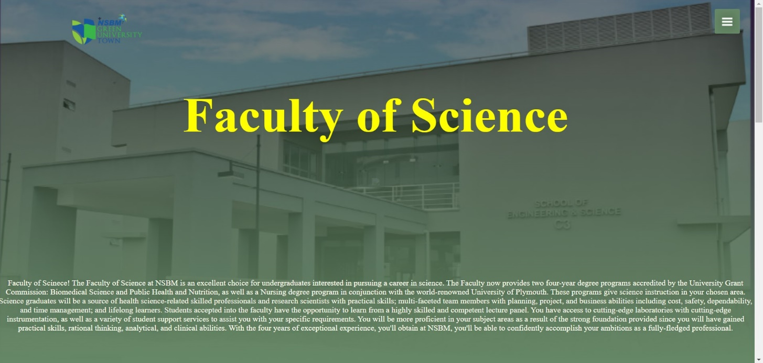

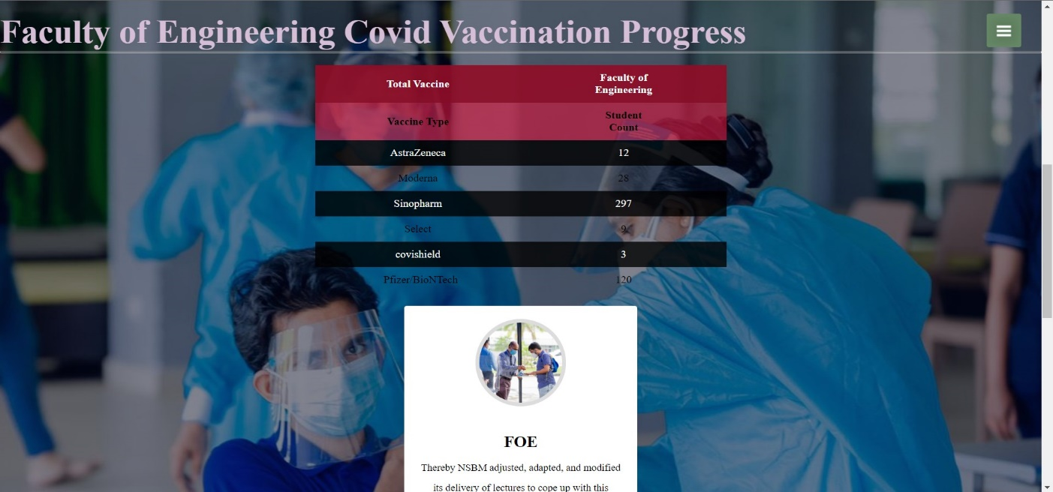

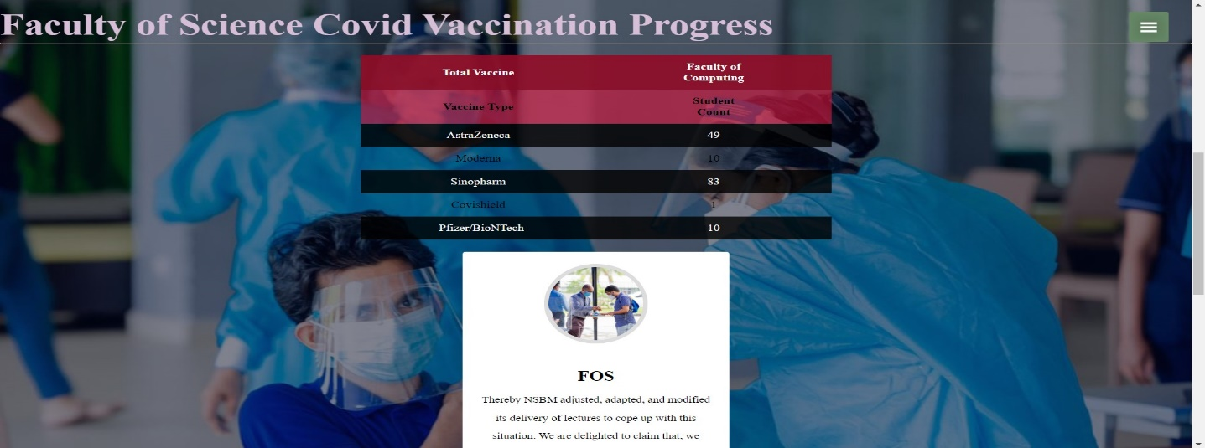

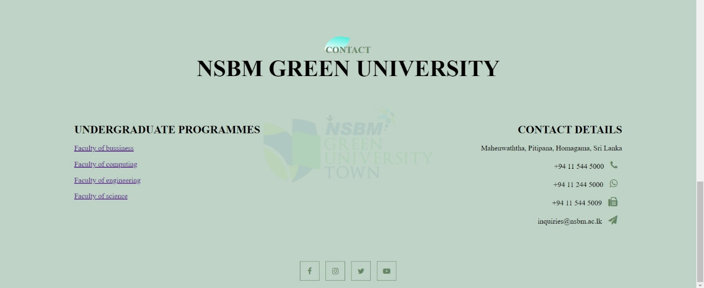

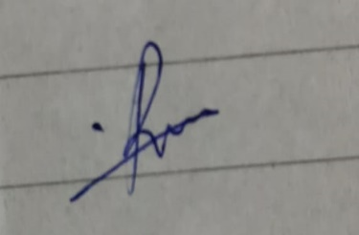

**R.A Paranagama’s Signature**

**C.S Wickramarachchi**

**24077**

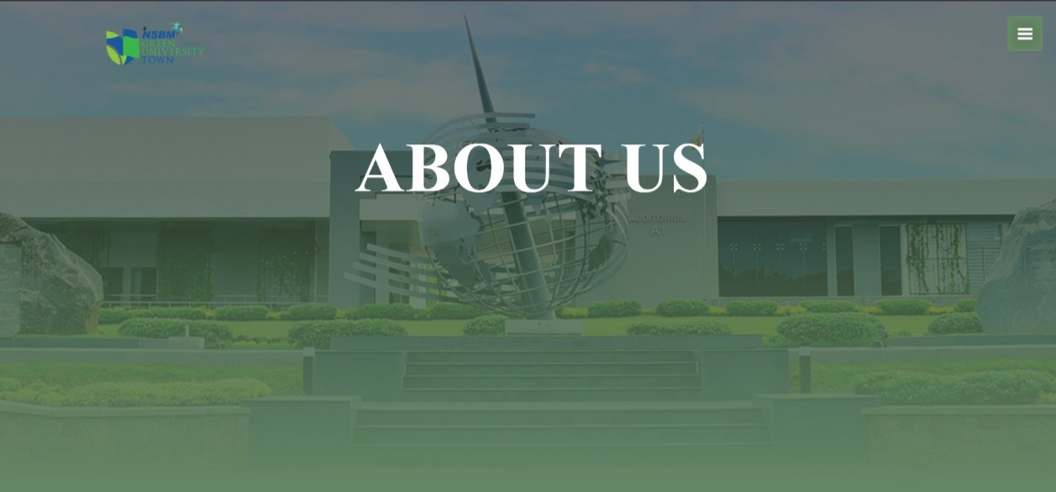

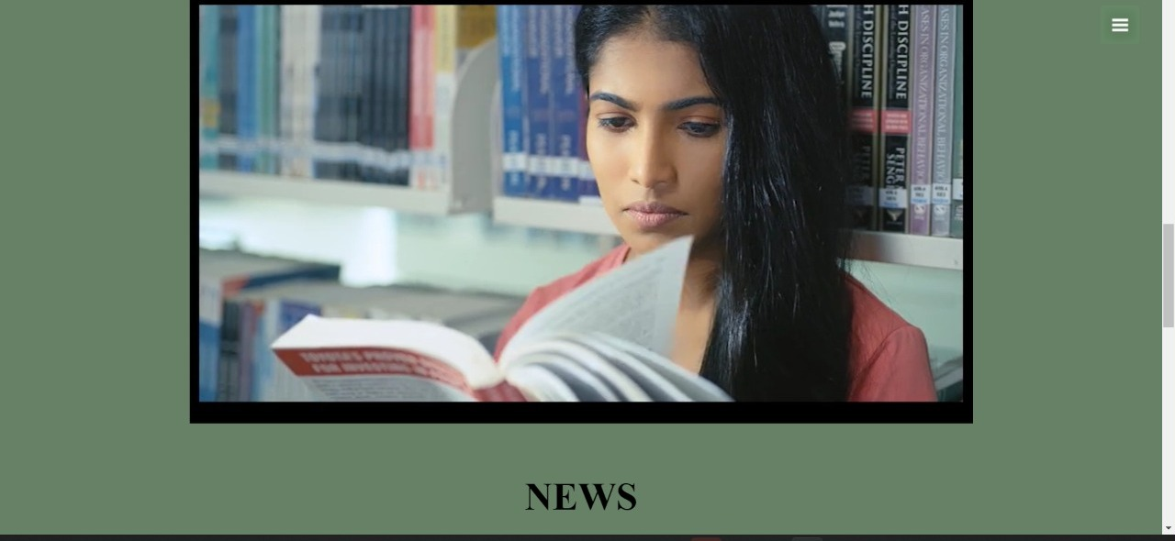

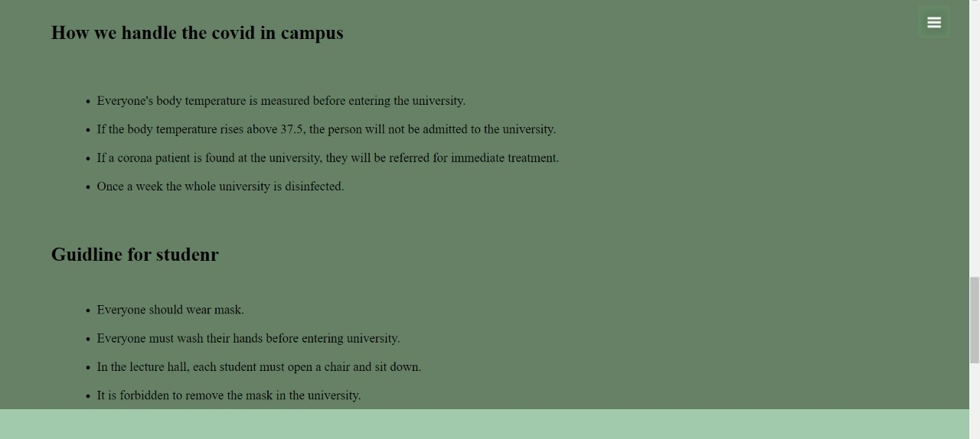

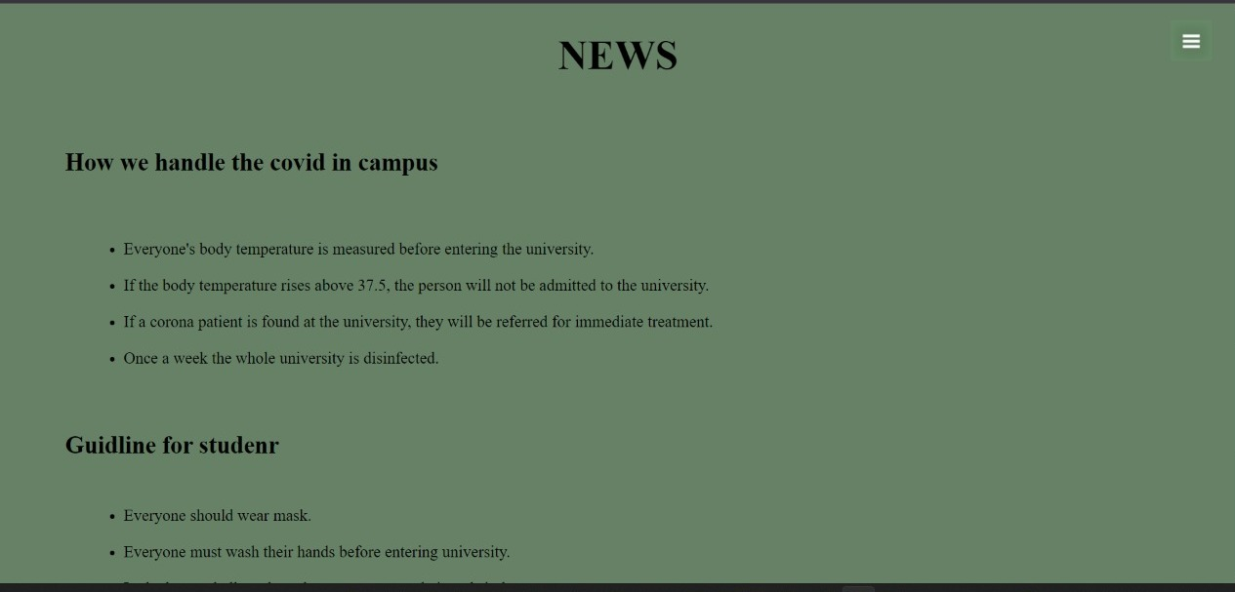

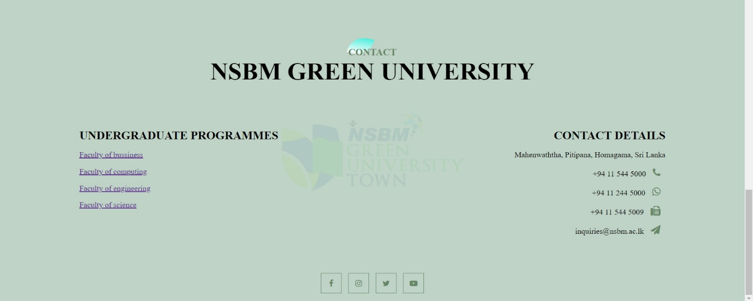

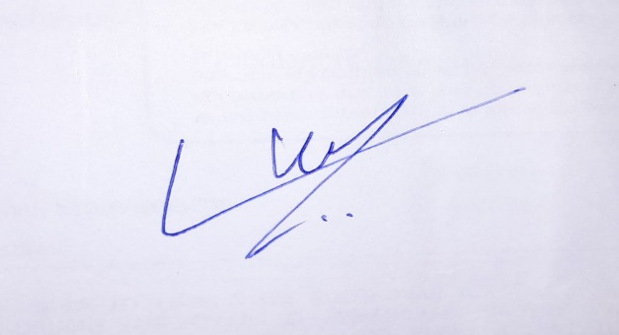

**C.S Wickramarachachi’s**

**Student Signature**

**C.D Malaviarachchi**

**23144**

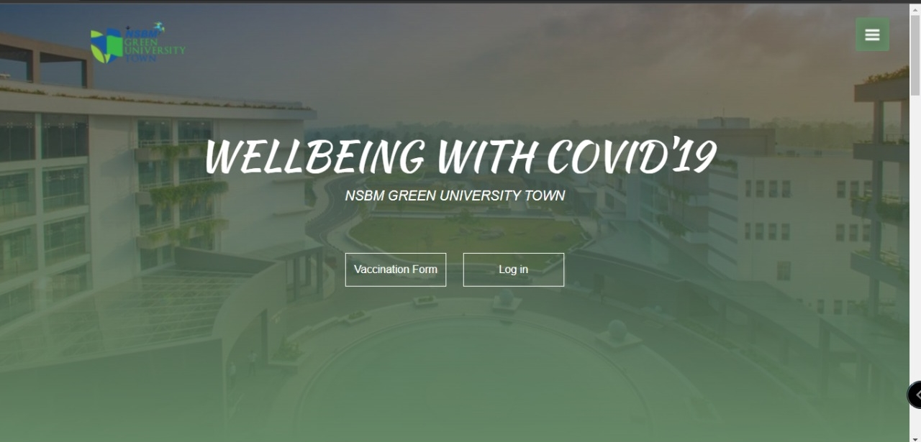

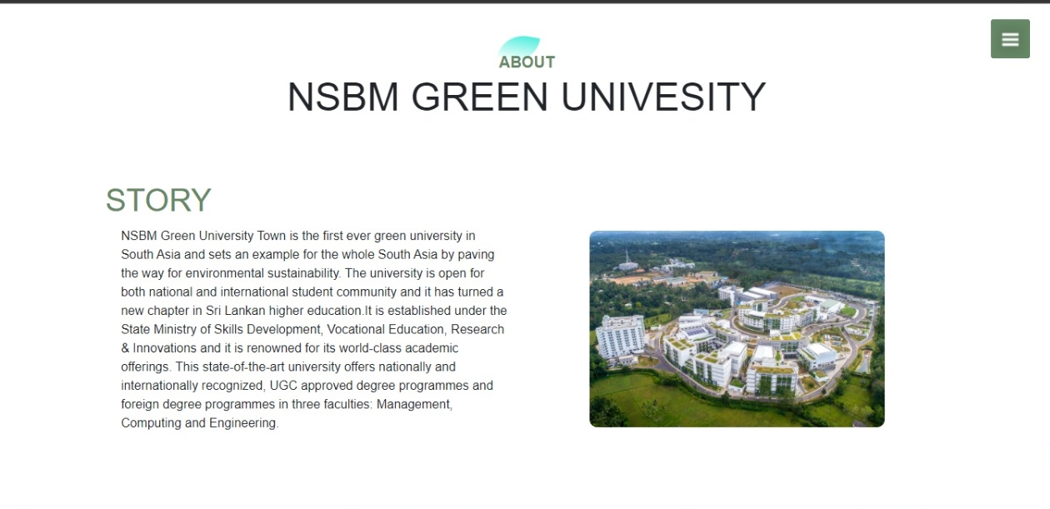

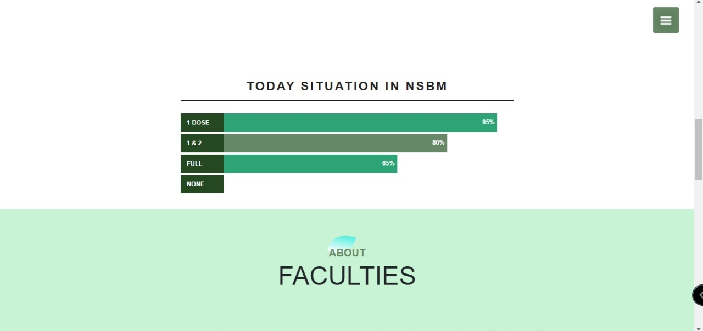

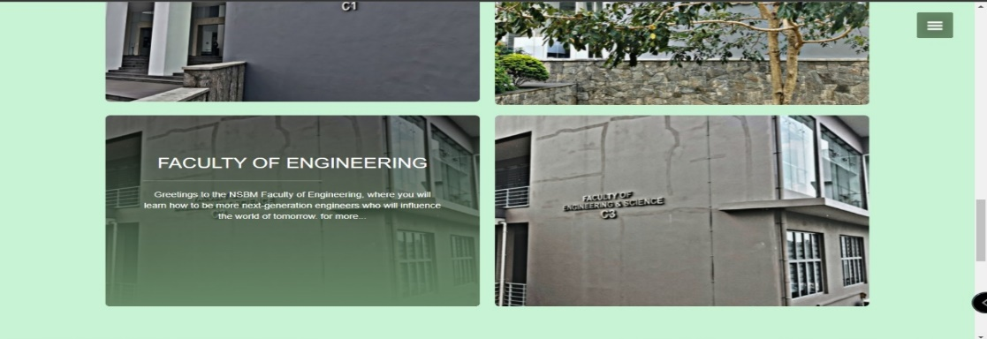

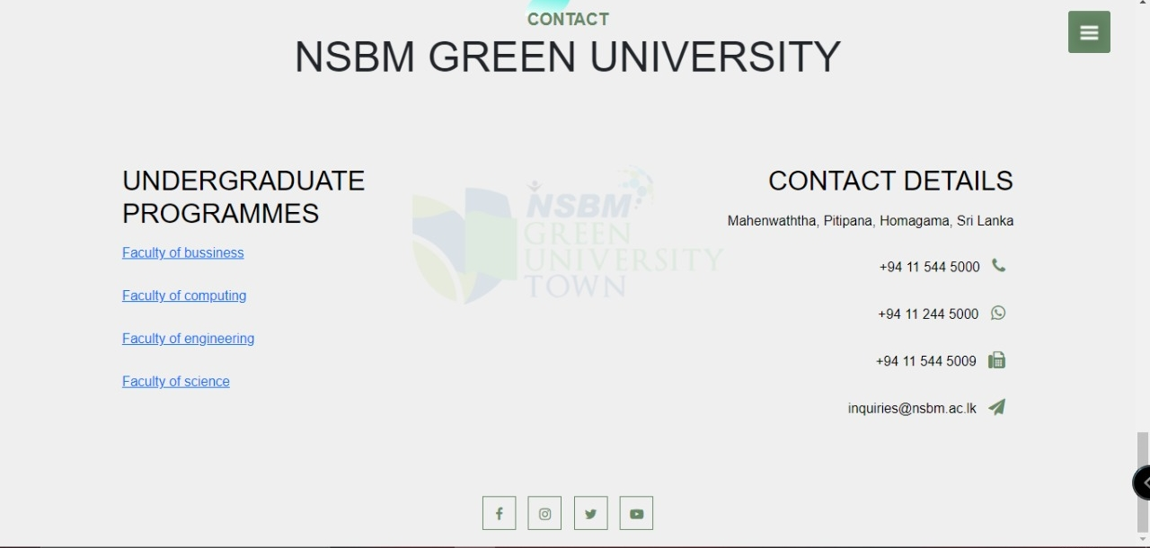

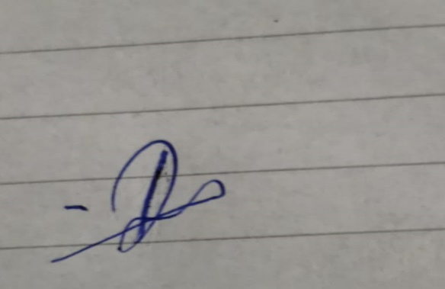

**C.D Malaviarachchi’s**

**Signature**

**D.N Sumali**

**22762**

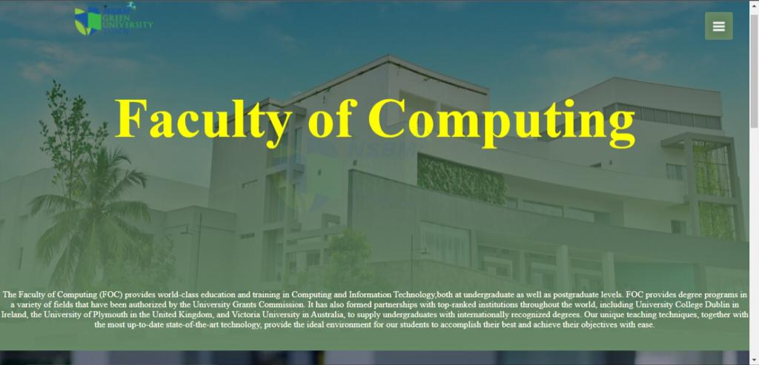

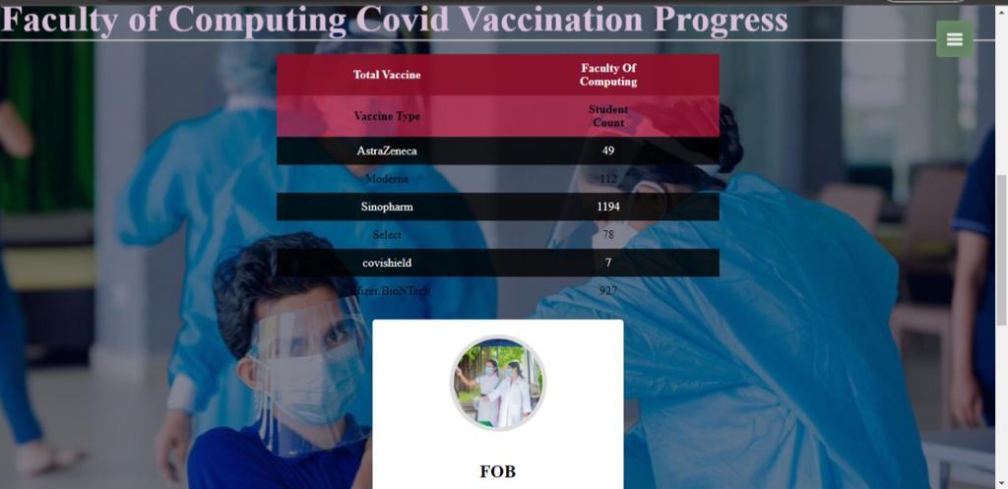

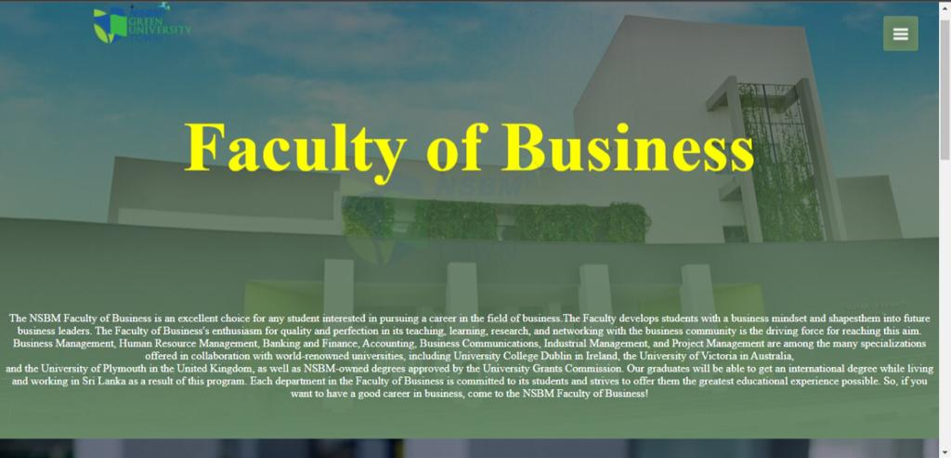

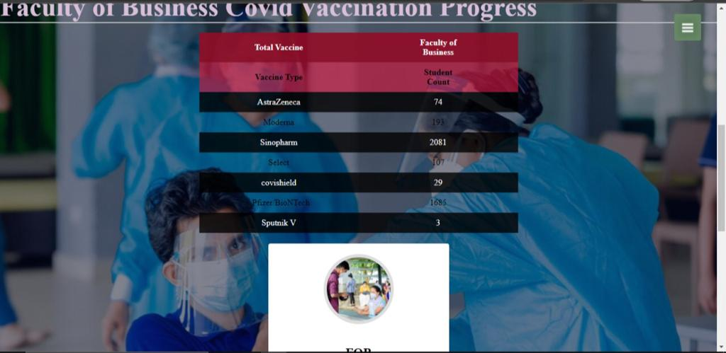

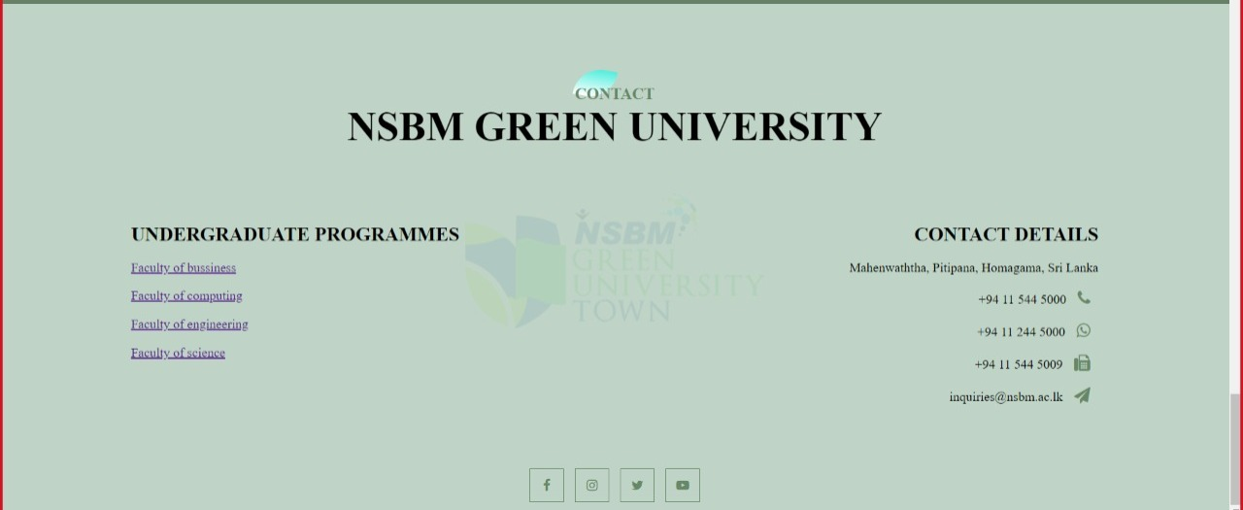

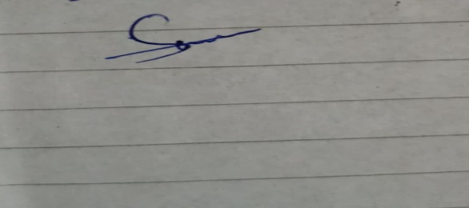

**D.N Sumali’s Signature**

**B.L.K Wanniarachchi**

**Index 22736**



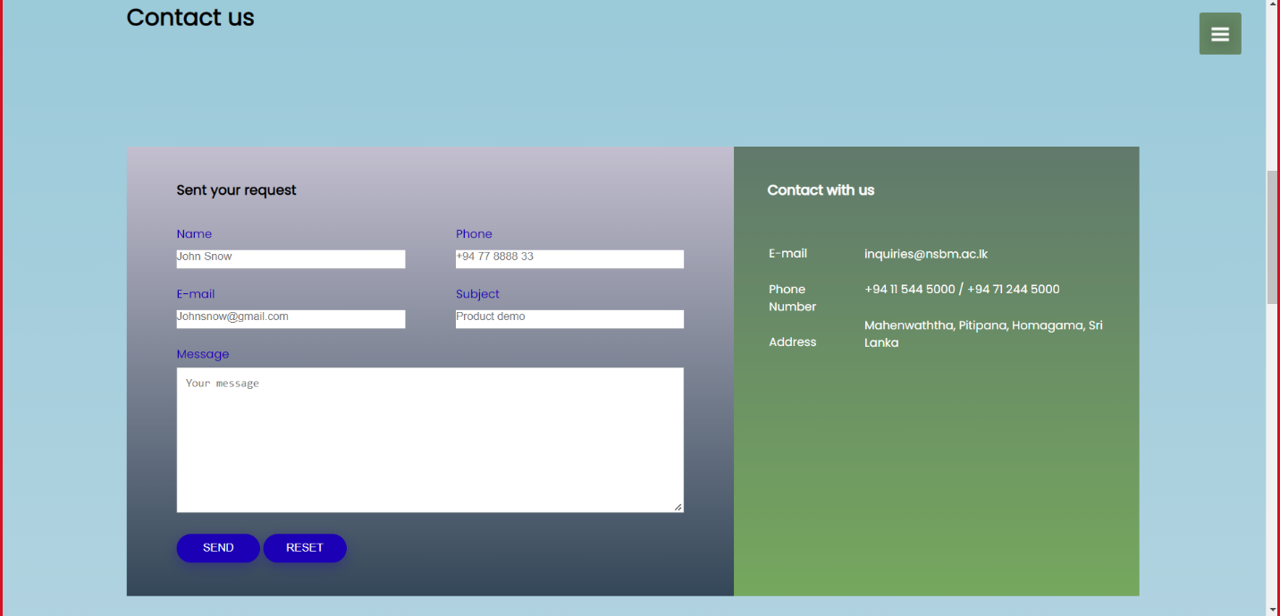

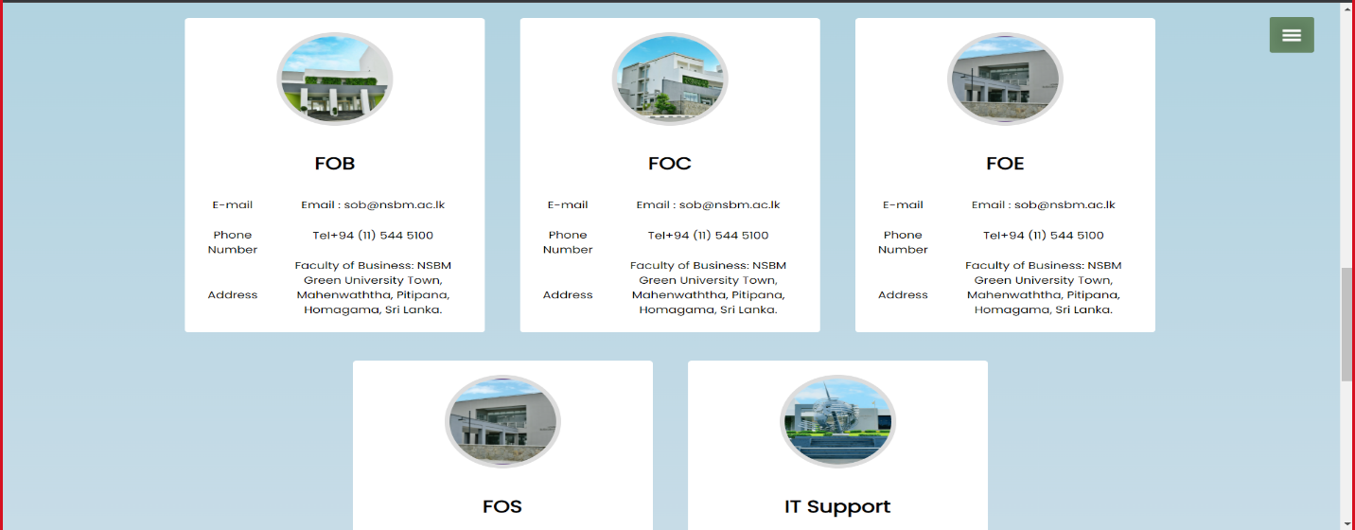

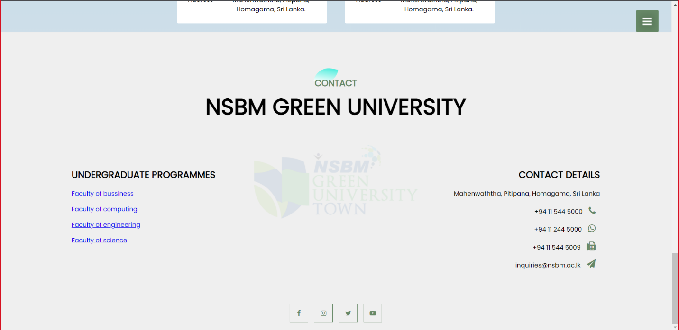

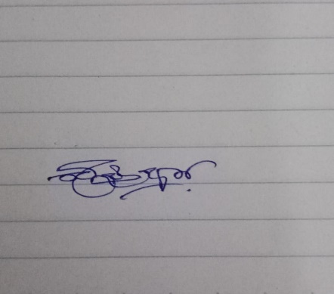

**B.L.K Wanniachchi’s Signature**

B.L.K Wanniachchi

**STUDENT DETAILS**

**Group No: 6**

**Team Leader Name: B.L.K Wanniarachchi**

**Faculty of Computing**

|  |  |
| --- | --- |
| **INDEX NUMBER** | **STUDENT NAME** |
| 22736 | B.L.K Wanniachchi |
| 23896 | R.A Paranagama |
| 23144 | C.S Wickramarachchi |
| 22762 | D.N Sumali |
| 23144 | C.D Malaviarachchi |